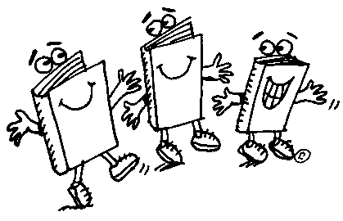
What Have You Read?
We want to know what books you have read! Are you a history buff, or do you love dark and scary mysteries? Fill out the form below by highlighting the titles you have read. If a book you’ve read isn’t listed, record it on the lines provided. Take this paper home over the weekend, and complete it by Tuesday, September 6th. Make sure you get your parent signature at the bottom as well.
Titles | Titles | Titles
Tales of a Fourth Grade Nothing  Frindle  Charlie and the Chocolate Factory  Babe, the Gallant Pig  Riding Freedom  Wayside School  Trumpet of the Swan  Sounder  True Confessions of Charlotte Doyle  Tuck Everlasting  Caddie Woodlawn  Pinballs  Dear Mr. Henshaw  Sadako and the 1000 Paper Cranes  My Teacher is an Alien  Chasing Redbird  Walk Two Moons  The 13th Floor  Johnny Tremain  From the Mixed Up Files….  The Chronicles of Narnia  Series of Unfortunate Events  Shiloh  Sing Down the Moon  Mrs. Frisby & the Rats of ….  Bridge to Terebithia  Because of Winn Dixie  Cricket in Times Square  Maniac Magee  Percy Jackson # ____________  The Hobbit  Julie of the Wolves  Anne of Green Gables  Beezus and Ramona  The Mouse and the Motorcycle  Captain Underpants # _______  Diary of a Wimpy Kid # ______  Goosebumps # ______________  Hotel for Dogs  The Hardy Boys # ___________ | Harry Potter # ______________  Summer of the Swans  The Hunger Games #_________  Old Yeller  Wrinkle in Time  Number the Stars  The Giver  The Golden Goblet  The Egypt Game  The Cay  The Black Pearl  Woodsong  The Westing Game  Time Warp Trio: _____________  Nancy Drew # ______________  Ramona the Brave  Ramona the Pest  The Miraculous Journey of Edward Tulane  The Mysterious Benedict Society  A Single Shard  Accidental Love  Al Capone Does My Shirts  Inkheart # _______  Hate that Cat/ Love that Dog  Matilda  My Brother Sam is Dead  My Side of the Mountain  By the Great Horn Spoon  Island of the Blue Dolphins  Call of the Wild  White Fang  Swindle  Clementine  The BFG  The Boy Who Saved Baseball  The Last Dragon Chronicles  Holes  Hoot  Flush | Alex Rider Adventure # ______  Artemis Fowl  Bone # __________  Brian’s Song  Bud, Not Buddy  Crispin  Poppy and Rye  Dogsong  Dragonwings  City of Ember  Gregor the Overlander  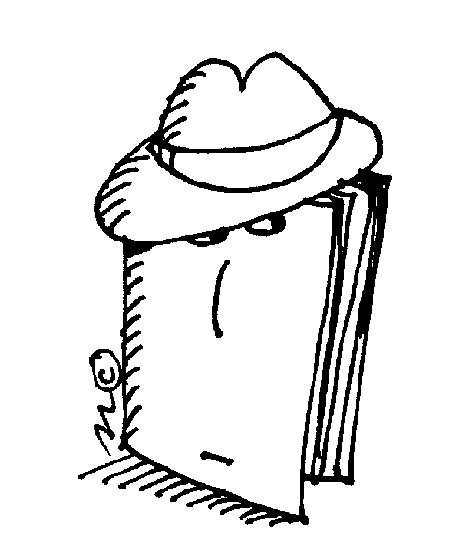  Esperanza Rising  Firegirl  Loser or Stargirl  Fever 1793  Flipped  Heat (Lupica)  Other Books You’ve Read:  ____________________________  ____________________________  ____________________________  ____________________________  ____________________________  ____________________________  ____________________________  ____________________________  ____________________________  ____________________________  ____________________________  ____________________________  ____________________________  ____________________________  ____________________________  ____________________________  ____________________________

Parent Signature: _______________________________________________ Date: ____________________

