[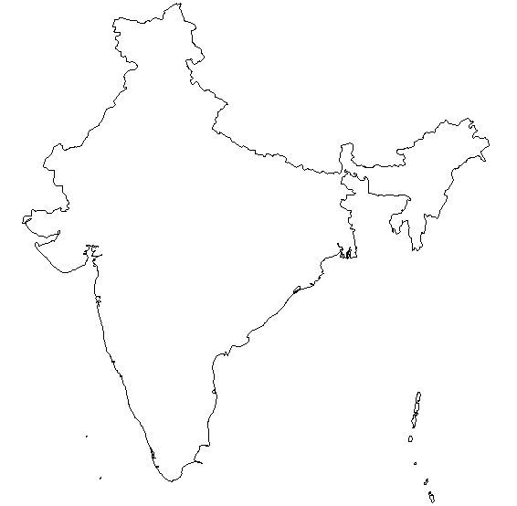](http://z.about.com/d/geography/1/0/n/J/india.jpg)